**Agile and Jira project ( shohoz.com)**

1. Go the the URL “shohoz.com”



1. Change the language into Bangla



1. Create an issue, consisting with Project name, Issue type, Summary, Description, Assignee, Reporter, Attachment screenshots of bug and click on the Create button in JIRA.

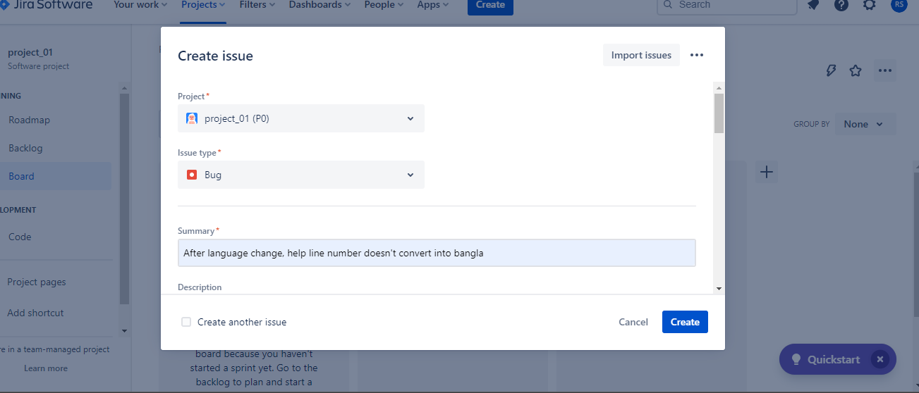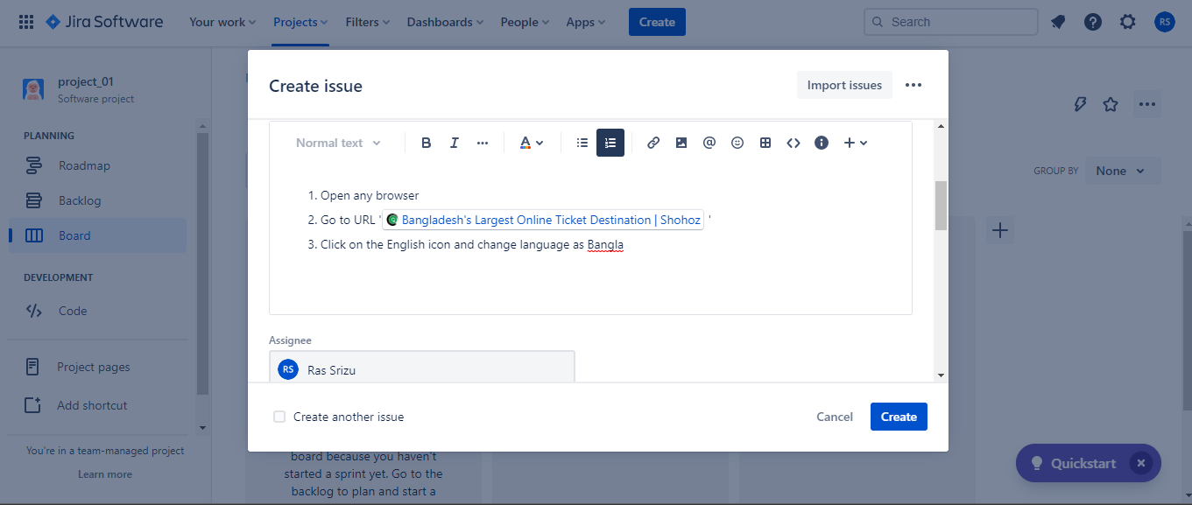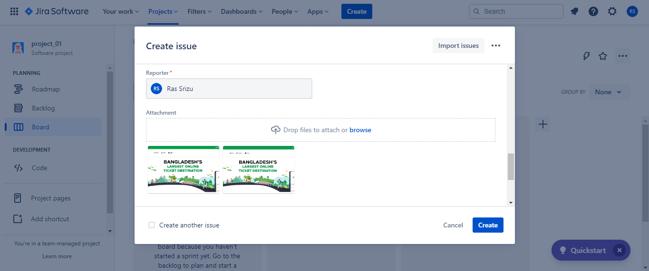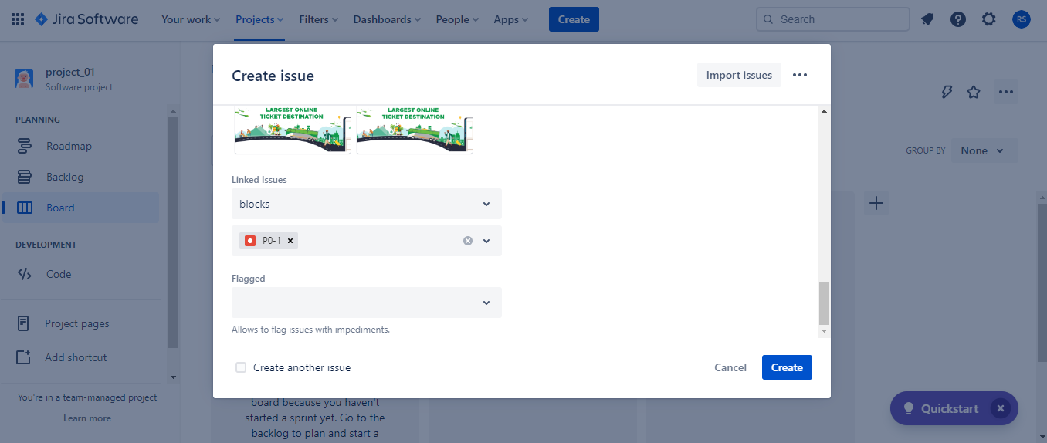

1. Add P0-4 epic

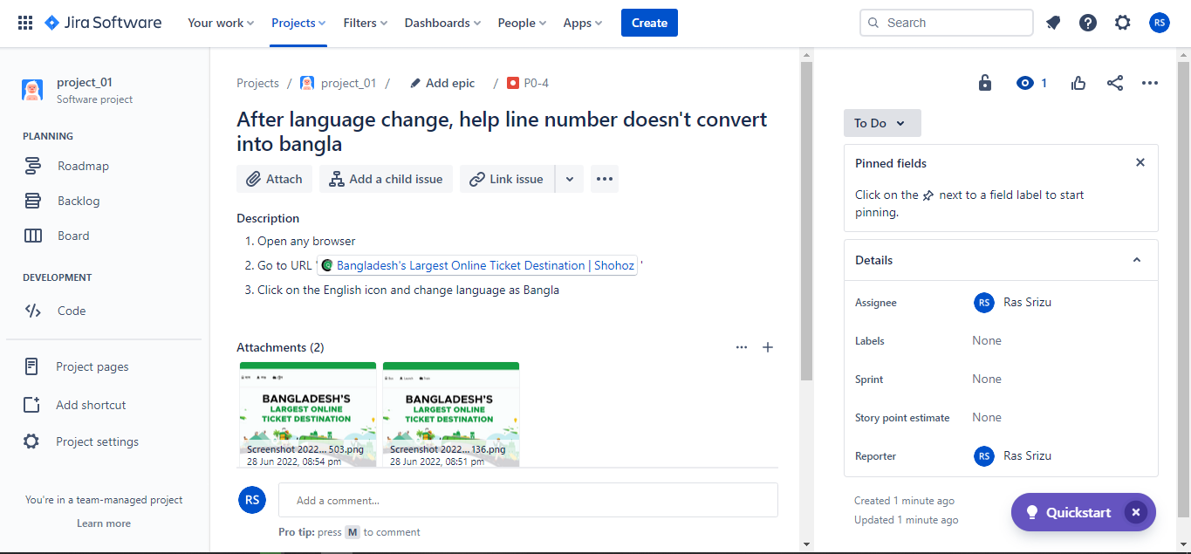

1. Start a sprint

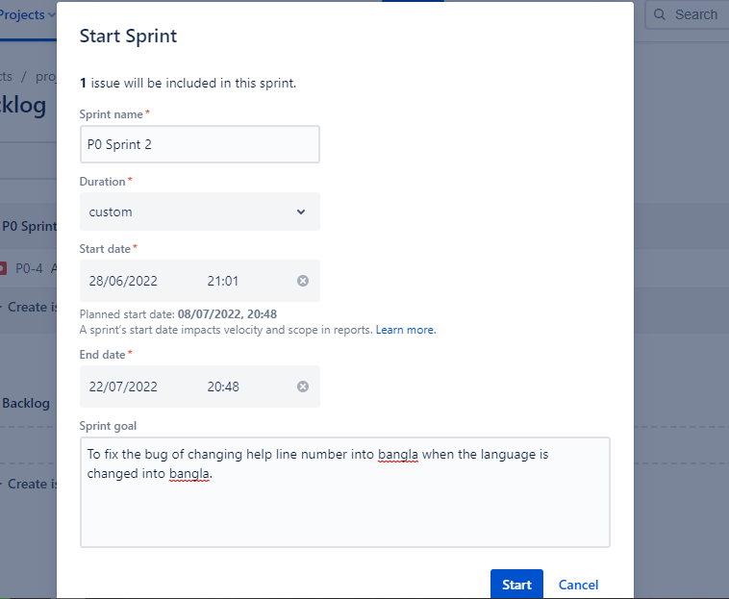

1. Issue the sprint to the developers.

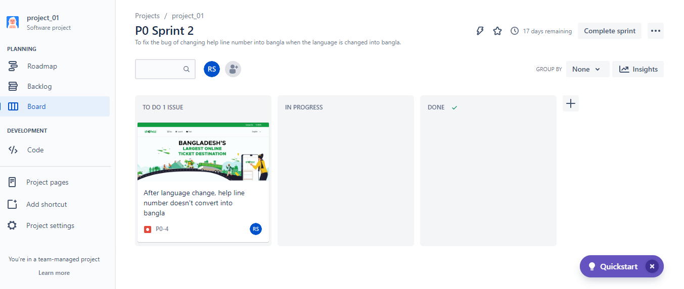

1. In progress

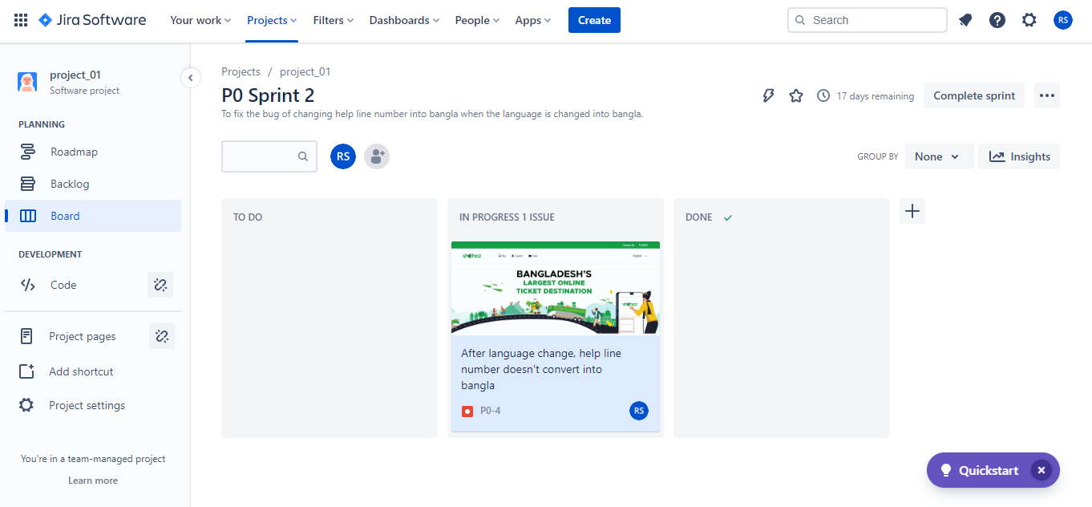

1. Done when the issue fixed.

